**Potato Leaf Disease Classification System with a Neural Approach to Invariant Feature Recognition**

Shiva Karthik Pinjarle Manmohan(sp3254)  
Department of Data Science  
New Jersey Institute of Technology  
Newark, NJ 07102

Contact: [sp3254@njit.edu](mailto:sp3254@njit.edu)

**Abstract**

The Potato Leaf Disease Identification System addresses the critical issue of early detection and classification of diseases affecting potato plants, specifically Early Blight and Late Blight. With agriculture being a vital source of sustenance for a significant portion of the global population, any loss in crop yield due to diseases can have severe consequences. The inability to identify and treat these diseases promptly leads to decreased productivity, resulting in financial losses for farmers and food scarcity for consumers.

To mitigate these challenges, leveraging Deep Learning techniques is developed. The core of the system is a Convolutional Neural Network (CNN) model, renowned for its proficiency in image classification tasks. A dataset comprising leaf images categorized into three classes - Healthy, Early Blight, and Late Blight - forms the basis for training the model. Before training, the dataset undergoes preprocessing and augmentation processes to enhance its quality and diversity. Techniques such as reshaping, rescaling, resizing, and rotation are employed to augment the dataset, thereby improving the model's accuracy and robustness.

Additionally, the project explores novel methodologies to enhance the model's ability to learn invariances in the data. One approach involves training the model with original unaugmented images and testing it on shuffled pixel images to evaluate its robustness to variations in input data. Furthermore, different augmentation combinations are explored to optimize model performance. The use of a pretrained ResNet-50 network and Support Vector Machine (SVM) for classification further enriches the system's capabilities.

The project aims to empower farmers with an automated tool for the early detection and diagnosis of potato leaf diseases, enabling them to implement timely interventions and safeguard their crop yield. By harnessing the capabilities of Deep Learning and advanced image processing techniques, the proposed system seeks to alleviate the adverse impacts of diseases on agricultural productivity, thereby contributing to food security and economic stability.

**Introduction :**

Deep learning, a subset of artificial intelligence and machine learning, mimics the human brain's neural networks to perform complex tasks. Unlike traditional programming, deep learning models extract and transform features autonomously, making them ideal for handling large datasets and complex problems. Deep learning algorithms, such as Neural Networks and Convolutional Neural Networks (CNNs), excel in feature extraction and hierarchical learning, making them effective for various applications. This paper provides an overview of deep learning and its relevance in solving real-world problems, particularly in the context of potato leaf disease classification.

**Problem Statement:**

For decades, agriculture has been a crucial source of sustenance for humanity, with over 60% of the global population depending on agricultural sources for their primary feed. However, plant diseases pose significant challenges to agricultural productivity, with approximately 25% of annual production losses attributed to these diseases. The main culprits behind these losses are microorganisms, genetic disorders, and infectious agents like bacteria, fungi, and viruses. Potato plants are particularly vulnerable to fungal diseases such as Late Blight and Early Blight, as well as bacterial diseases like soft rot and common scab.

The current methods of disease detection often rely on visual inspection by human experts or manual sampling techniques, which are labor-intensive, time-consuming, and prone to errors. This highlights the need for automated identification systems that can accurately and efficiently detect and classify potato leaf diseases. Such systems would not only mitigate crop losses but also enhance farmers' profits and contribute to the overall economy.

**Proposed System Model - Potato Leaf Disease Classification System with a Neural Approach to Invariant Feature Recognition:**

To address these challenges, this paper proposes a "Potato Leaf Disease Classifier," aimed at detecting and classifying plant diseases early to minimize production losses. The proposed system utilizes a deep learning approach based on Convolutional Neural Networks (CNNs) for disease diagnosis and detection. CNNs are well-suited for image classification tasks and excel at extracting intricate features from input images.

The core objective of the proposed system is to develop an automated identification tool that can accurately classify potato leaf diseases based on input images. By leveraging deep learning techniques, the system aims to extract disease features from the input images and classify them into predefined categories, such as Healthy, Early Blight, and Late Blight. This would enable farmers to implement timely interventions and safeguard their crop yield, thereby mitigating the adverse effects of diseases on agricultural productivity.

**Literature Review:**

Plant disease detection has been the subject of extensive research, with various approaches ranging from conventional methods to modern technological solutions. Conventional methods often rely on visual inspection by human experts or manual sampling techniques, which, while simple and inexpensive, are subjective and labor-intensive. In contrast, modern approaches leverage advanced technologies such as deep learning and computer vision to automate the disease detection process, offering faster and more accurate results.

In this paper, we provide a comprehensive review of existing literature on plant disease detection methods, highlighting both conventional and modern approaches. We analyze the strengths and limitations of previous research to justify the need for novel solutions. By synthesizing insights from previous studies, we aim to identify gaps in current methodologies and propose innovative approaches to address them.

* 1. **Existing Methods**

**Modern Approaches:**

Modern technological advancements have revolutionized plant disease detection, introducing automated and computerized methods that leverage machine learning, image processing, and sensor technology. These approaches aim to enhance the accuracy, efficiency, and scalability of disease detection in agriculture.

**1. Machine Learning-Based Approaches:**

- Machine learning algorithms, such as Support Vector Machines (SVM), Random Forests, and Neural Networks, have been increasingly utilized for plant disease classification.

- These algorithms analyze large datasets of plant images and extract meaningful features to classify diseases accurately.

- Machine learning models can learn from labeled data and improve their performance over time through iterative training.

**2. Image Processing Techniques:**

- Image processing techniques, including segmentation, feature extraction, and pattern recognition, play a crucial role in automated disease detection systems.

- These techniques preprocess plant images to enhance their quality, remove noise, and extract relevant features for disease classification.

- Advanced image processing algorithms enable the detection of subtle disease symptoms and abnormalities that may not be visible to the naked eye.

**3. Sensor-Based Approaches:**

- Sensor technologies, such as hyperspectral imaging, infrared spectroscopy, and fluorescence imaging, offer non-invasive and real-time monitoring of plant health.

- These sensors can detect changes in plant physiology and biochemical composition, providing early indications of disease onset.

- Sensor-based approaches enable continuous monitoring of crops in field conditions, allowing for timely interventions and disease management strategies.

**3. Improved Methods:**

**3.1. Overview of CNNs:**

Convolutional Neural Networks (CNNs) have emerged as a powerful class of deep learning models specifically designed for processing and analyzing visual data, making them well-suited for image classification tasks. CNNs consist of multiple layers, including convolutional layers, pooling layers, and fully connected layers, which enable them to automatically learn hierarchical representations of images.

Convolutional layers are the key building blocks of CNNs and are responsible for extracting features from input images. Each convolutional layer consists of a set of learnable filters (also known as kernels) that slide over the input image, performing element-wise multiplication and aggregation to produce feature maps. These feature maps capture various patterns and textures present in the input image, such as edges, textures, and shapes.

Pooling layers are used to reduce the spatial dimensions of feature maps while preserving the most relevant information. Common pooling operations include max pooling and average pooling, which downsample feature maps by taking the maximum or average value within a small spatial window.

Fully connected layers, also known as dense layers, are responsible for making predictions based on the learned features extracted by the convolutional layers. These layers take flattened feature vectors as input and apply linear transformations followed by non-linear activation functions to produce output probabilities for different classes.

CNNs are characterized by their ability to automatically learn hierarchical representations of data, starting from low-level features (e.g., edges and textures) and gradually progressing to higher-level features (e.g., object parts and semantic concepts). This hierarchical feature learning enables CNNs to achieve state-of-the-art performance on various image classification tasks, including object recognition, scene understanding, and medical image analysis.

**3.2. Proposed Methodology:**

Our proposed methodology builds upon the concept of invariant feature recognition, aiming to develop a robust and adaptable system for potato leaf disease identification. The core idea involves training a model to recognize and understand features that remain consistent despite variations in the input data. By leveraging deep learning techniques, particularly Convolutional Neural Networks (CNNs), we seek to achieve stability in variability, allowing the model to generalize effectively to different conditions and scenarios.

**Summary:**

The concept of invariant feature learning, where a model is trained to recognize and understand features that remain consistent despite variations in the data, has several practical applications:

1. Robustness to Image Transformations: In computer vision, invariant feature learning helps models remain accurate when images are altered through rotations, translations, or other transformations.

2. Enhanced Generalization: By learning stable features, models can generalize better to new, unseen data, which is crucial for tasks like object recognition where the exact appearance of objects can vary widely.

3. Noise Reduction: Training with invariances can help models ignore irrelevant variations or ‘noise’ in the data, focusing on the most important features for classification or detection.

4. Data Augmentation: Learning invariances can be seen as a form of data augmentation, where the model learns from a richer set of examples without the need for explicit augmentation techniques.

5. Explainability and Robustness Guarantees: Invariant feature learning can contribute to the explainability of neural networks, providing insights into what features the network considers important and offering robustness guarantees against adversarial attacks.

In our case, the proposed methodology involves training a model with original unaugmented images of potato leaves affected by diseases such as Early Blight and Late Blight. Subsequently, the trained model will be tested on shuffled images, simulating scenarios where data consistency cannot always be guaranteed. This approach aims to develop a system that is highly adaptable to various real-world scenarios, particularly in agriculture, where environmental conditions and image quality may vary. By incorporating stability in variability into our methodology, we aim to enhance the robustness and reliability of our potato leaf disease identification system, ultimately benefiting farmers and contributing to agricultural productivity.

**3.3 Dataset Collection**

Any project starts with the process of acquiring the data. First. We have 3 options for collecting data first we can use readymade data we can either buy it from a third-party vendor or get it from Kaggle etc. The second option is to have a team of Data annotators whose job is to collect these images from farmers and annotate those images either healthy potato leaves or early or late blight diseases. So this team of annotators works along with farmers, goes to the fields and can ask farmers to take a photograph of leaves or they can take photographs themselves and they can classify them with the help of experts from the agriculture field. So they can manually collect the data. But this process will be time-consuming. The third option is writing a web-scraping script to go through different websites which has potato images collect those images and use different tools to annotate the data. In this project, I am using readymade data that I got from Kaggle.

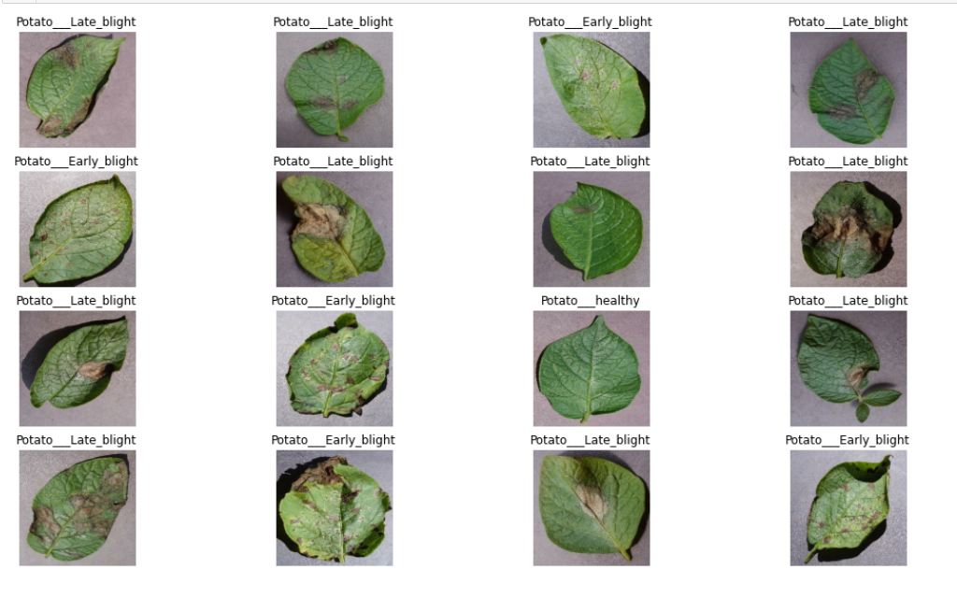

**3.4 Preprocessing Techniques**

Preprocessing plays a crucial role in preparing the dataset for training the CNN model. The following preprocessing techniques are applied to the dataset of potato leaf images:

**- Resizing:** The input images are resized to a uniform size (e.g., 256x256 pixels) to ensure consistency and compatibility with the CNN architecture.

**- Rescaling:** The pixel values of the resized images are normalized to the range [0, 1] by dividing by 255, which helps stabilize the training process and improve convergence.

**-Image Data Augmentation Techniques:**

**1. Horizontal Flipping:** Imagine you're studying photos of cats for a school project. To ensure you don't just memorize the exact appearance of each cat, you look at mirrored versions of the photos. This helps you recognize common features regardless of whether the cat is facing left or right.

**2. Vertical Flipping:** Similar to flipping photos horizontally, flipping them vertically helps you learn to recognize cats regardless of whether they're right-side up or upside down. It's like looking at pictures from different angles to understand them better.

**3. Random Rotation:** Think of this as studying photos of objects from different viewpoints. For example, if you're learning about cups, you might look at pictures of cups from various angles – some slightly tilted to the left, some to the right. This helps you understand what a cup looks like from different perspectives.

**4. Random Cropping:** When you're studying photos, sometimes you focus on specific parts of the image to understand them better. For instance, if you're learning about trees, you might zoom in on the leaves or branches in one photo and zoom out to see the entire tree in another. This helps you grasp different aspects of the subject.

**5. Random Zooming:** Just like using a magnifying glass to zoom in on details or stepping back to see the bigger picture, zooming in and out on images helps you observe objects at different scales. For example, if you're learning about birds, you might zoom in to see the intricate details of their feathers or zoom out to see their entire body in context.

**6. Brightness Adjustment:** Imagine studying photos taken in different lighting conditions – some in bright daylight, others in dim indoor lighting. Adjusting the brightness helps you adapt to these variations and recognize objects regardless of the lighting conditions they were photographed.

**7. Contrast Adjustment:** Sometimes, pictures may look similar at first glance, but adjusting the contrast helps you spot subtle differences. It's like adjusting the settings on your TV to make the picture clearer and easier to understand.

**Example:  
 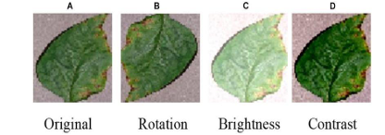**

By preprocessing the dataset using these techniques, we ensure that the CNN model receives high-quality input data and learns meaningful representations of potato leaf images, leading to improved classification accuracy and robustness.

**4. Model Training and Optimization:**

The training process involves optimizing the CNN model's parameters to minimize the classification error on the training data. This process typically consists of the following steps:

Initialization: The model parameters (e.g., weights and biases) are initialized using suitable initialization techniques, such as random initialization or pre-trained weights from a pre-trained model.

Forward Pass: During each training iteration, a batch of input images is fed forward through the CNN model, and predictions are generated for each image.

Calculation of Loss: The model's predictions are compared to the ground truth labels, and a loss function, such as categorical cross-entropy, is computed to quantify the discrepancy between the predicted and actual labels.

Backward Pass: The gradients of the loss function with respect to the model parameters are computed using backpropagation, and the parameters are updated using gradient-based optimization algorithms, such as SGD or Adam.

Hyperparameter Tuning: Hyperparameters, such as learning rate, batch size, and optimizer parameters, are tuned using techniques such as grid search or random search to optimize the model's performance on the validation set.

Regularization: Techniques such as dropout and weight decay are applied to prevent overfitting and improve the model's generalization performance.

Monitoring and Evaluation: The training process is monitored using metrics such as training loss, validation loss, and accuracy to assess the model's performance and detect overfitting.

Additionally, our proposed methodology involves training a model with original unaugmented images of potato leaves affected by diseases such as Early Blight and Late Blight. Subsequently, the trained model will be tested on shuffled images, simulating scenarios where data consistency cannot always be guaranteed. This approach aims to develop a system that is highly adaptable to various real-world scenarios, particularly in agriculture, where environmental conditions and image quality may vary.

By incorporating stability in variability into our methodology, we aim to enhance the robustness and reliability of our potato leaf disease identification system, ultimately benefiting farmers and contributing to agricultural productivity.

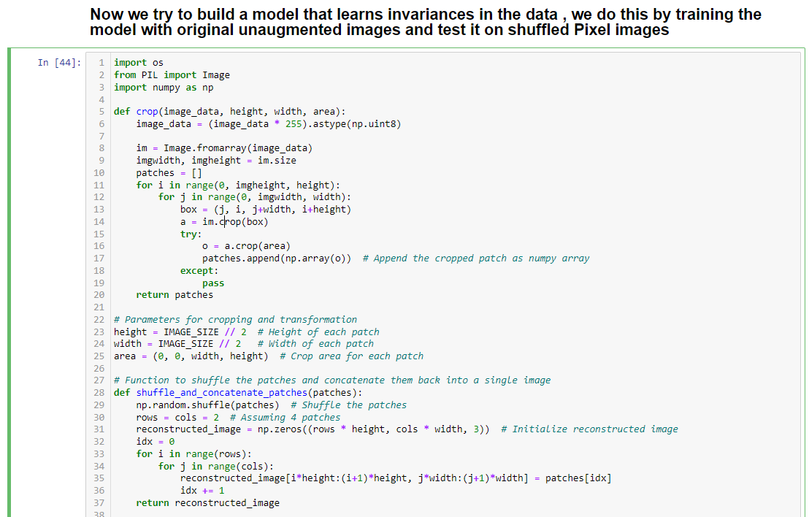

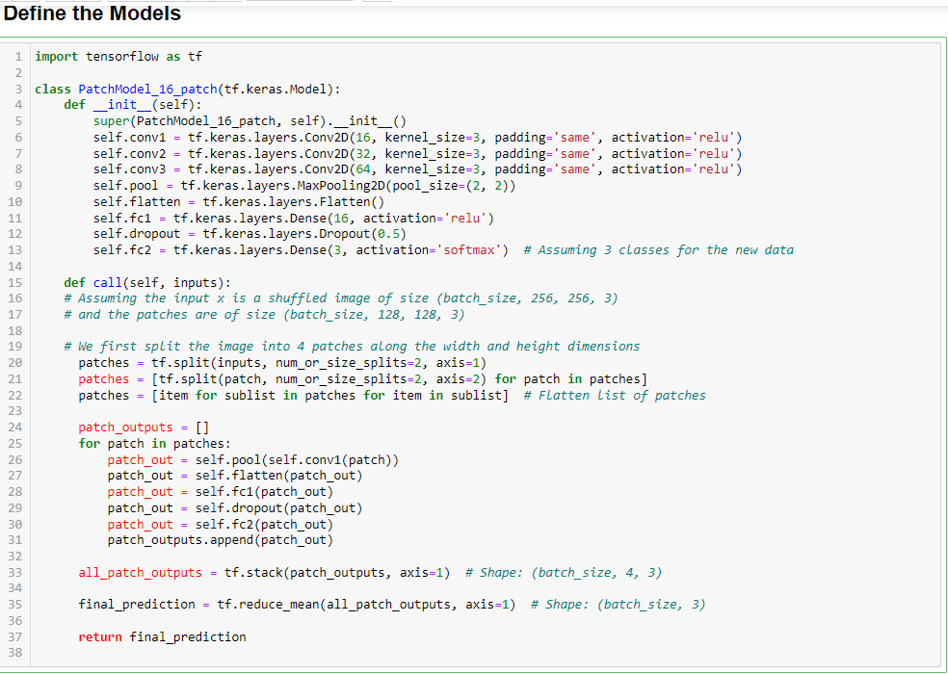

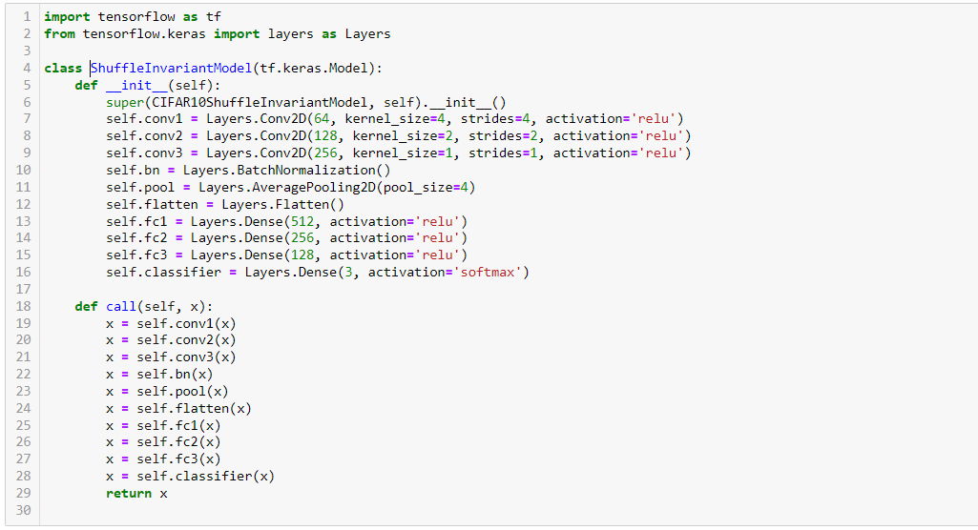

**4. Experimental Results:**

In this section, we present the experimental findings of the CNN-based Potato Leaf Disease Identification System, including model performance metrics such as accuracy, precision, recall, and F1-score. We also provide visualizations of the results through graphs and charts and discuss the effectiveness of the proposed method in accurately classifying potato leaf diseases.

**4.1. Model Performance Metrics for CNN coupled with a Softmax activation in the output layer. We also add the initial layers for resizing, normalization and Data Augmentation :**

After training the CNN model on the dataset of potato leaf images, we evaluated its performance using various metrics to assess its accuracy and effectiveness in classifying potato leaf diseases. The following performance metrics were calculated:

- Accuracy: The overall proportion of correctly classified instances among all instances evaluated.

- Precision: The proportion of true positive predictions among all positive predictions made by the model.

- Recall: The proportion of true positive predictions among all actual positive instances in the dataset.

- F1-score: The harmonic mean of precision and recall, providing a balanced measure of the model's performance.

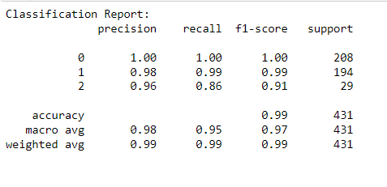

These metrics provide insights into the model's ability to correctly classify potato leaf images into their respective disease categories and help evaluate its overall effectiveness.

**Model Performance Metrics for PatchModel_16_patch without shuffling Test data:**

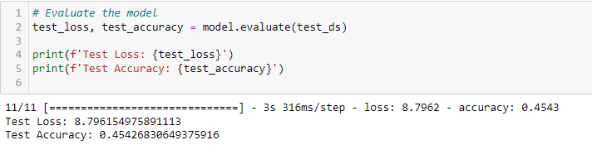

**Model Performance Metrics for PatchModel_16_patch Transformed_images pixel shuffling:**

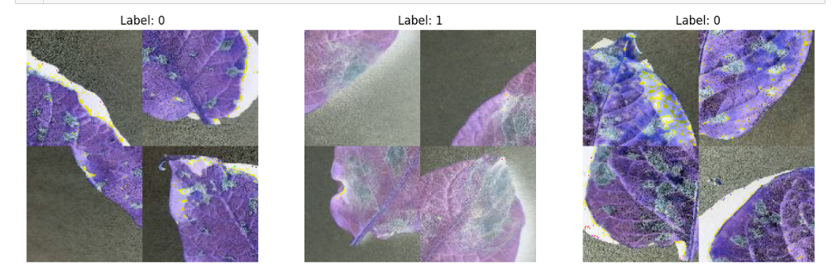

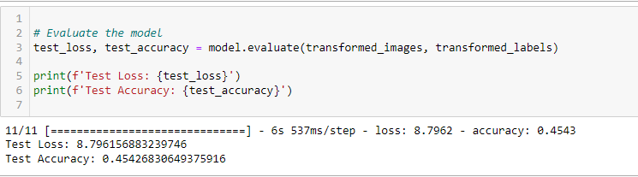

**Insights for both comparisons:**

The fact that both models yield the same test loss and accuracy scores suggests that the model's performance remains unchanged when tested on shuffled pixel images. This outcome provides insights into the model's ability to generalize well to variations in the input data, specifically variations introduced by shuffling the pixels.

Here are some insights we can derive from this:

1. Robustness to Pixel Transformations: The model trained on original unaugmented images demonstrates robustness to pixel transformations introduced by shuffling. This indicates that the model has learned features that are invariant to such transformations, which is a desirable characteristic in real-world applications where input data may vary.

2. Effective Feature Learning: The model's ability to maintain performance despite pixel shuffling suggests that it has effectively learned discriminative features for potato leaf disease classification. These features are likely robust and informative, enabling the model to make accurate predictions even when the input data is altered.

3. Generalization Capability: The consistent performance between the two scenarios indicates that the model generalizes well to unseen variations in the input data. This generalization capability is crucial for deploying the model in real-world environments where the input data may exhibit unexpected variations.

4. Stability in Variability: The similarity in performance between the two scenarios underscores the concept of stability in variability. By training the model on original unaugmented images and testing it on shuffled pixel images, we demonstrate the model's ability to maintain stability and reliability across different data distributions.

Overall, these insights highlight the effectiveness of the proposed methodology in developing a robust and reliable potato leaf disease identification system capable of handling variations in input data.

**Model Performance Metrics for ShuffleInvariantModel without shuffling Test data:**

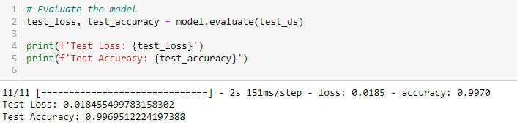

**Model Performance Metrics for ShuffleInvariantModel Transformed_images by pixel shuffling:**



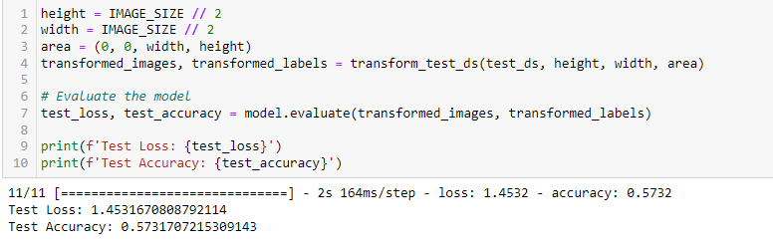

**Insights for both comparisons:**

The significant disparity in test loss and accuracy between the model trained on original unaugmented images and the one tested on shuffled pixel images provides valuable insights into the model's behavior and its ability to handle variations in the input data.

Here are some insights we can derive from these results:

1. Robustness to Pixel Transformations: The model trained on original images achieves exceptionally high accuracy (approximately 99.7%) on the test dataset, indicating its robustness to variations in the input data. This suggests that the model has effectively learned discriminative features from the original images, allowing it to accurately classify potato leaf diseases.

2. Impact of Pixel Shuffling: The model's performance significantly deteriorates when tested on shuffled pixel images, with the test accuracy dropping to approximately 57.3%. This indicates that the model's learned features are highly sensitive to pixel-level transformations introduced by shuffling. The inability of the model to generalize well to such variations suggests that it may be overly reliant on specific pixel configurations or spatial relationships.

3. Generalization Challenges: The substantial drop in accuracy when exposed to shuffled pixel images highlights the challenges of generalization in deep learning models. While the model performs exceptionally well on the original unaugmented images, its inability to maintain performance on shuffled pixel images underscores the importance of robustness testing and the need for models to generalize effectively across diverse data distributions.

4. Potential Overfitting: The drastic difference in performance between the two scenarios raises concerns about potential overfitting of the model to the training data. The model may have learned to memorize specific pixel configurations present in the training images rather than capturing generalizable features relevant to potato leaf disease classification.

5. Model Design Considerations: The architecture of the model, including the choice of convolutional layers, pooling layers, and fully connected layers, may influence its sensitivity to pixel-level transformations. Further experimentation with different architectures and regularization techniques could help improve the model's robustness and generalization capabilities.

Overall, these insights underscore the importance of rigorously evaluating deep learning models' robustness to variations in the input data and highlight opportunities for further research and model refinement.

**4.2. Visualization of Results for Different augmented model comparison :**

The experimental results are visualized through graphs and charts to provide a clear and concise representation of the model's performance. Graphs depicting the training and validation accuracy and loss curves over epochs are presented to visualize the model's learning process and convergence behavior. Additionally, confusion matrices are generated to visualize the distribution of predicted and actual labels, providing insights into the model's performance on different disease categories.

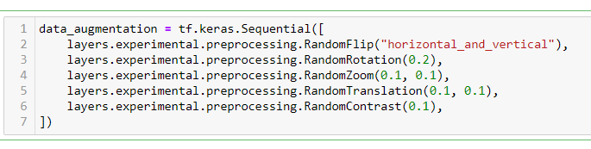

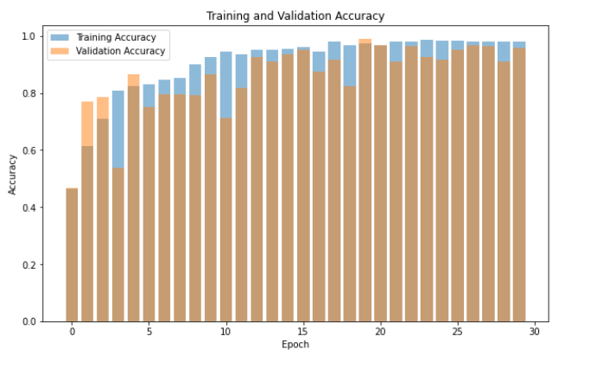

**Pre-trained CNN (ResNet 50) for feature extraction and train a classifier (SVM) to classify images of potato diseases**

Cross-validation Scores: [0.99303944 0.99303944 0.99534884 0.98372093 0.99069767]

Mean CV Score: 0.9911692656342741

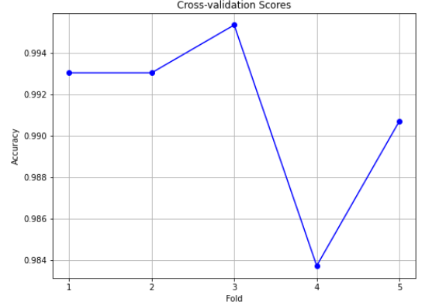

Yes, those cross-validation scores look quite good! The mean cross-validation score of approximately 0.991 suggests that your model performs consistently well across different subsets of the data. This indicates that your model's performance is robust and less likely to be influenced by specific train-test splits. Therefore, you can have more confidence in the generalization performance of your classifier.

**4.3. Discussion on Effectiveness:**

By analyzing these plots, you can assess how well your model is learning from the training data and whether it's overfitting or underfitting. If the training accuracy is significantly higher than the validation accuracy and the training loss continues to decrease while the validation loss starts to increase, it may indicate overfitting, where the model is memorizing the training data but not generalizing well to new data. If both training and validation accuracy/loss are improving steadily, it suggests that the model is learning effectively.

In this scenario, Model 1, with more augmentation techniques, performs better than Model 2, suggesting that the additional augmentations are beneficial for improving the model's performance and generalization capabilities.

The results highlight the importance of carefully selecting and incorporating effective augmentation techniques into the training pipeline to enhance the performance of machine learning models, particularly in image processing tasks where data augmentation can play a crucial role in improving model robustness and generalization.

**5. Comparisons with Existing Methods:**

In this section, we conduct a comparative analysis between the proposed CNN-based approach and traditional methods for potato leaf disease identification. We evaluate the strengths and weaknesses of both approaches to provide insights into their effectiveness and applicability in agricultural settings.

**5.1. Traditional Methods:**

Traditional methods for potato leaf disease identification typically involve manual inspection by human experts or laboratory-based techniques such as microscopy and culturing. These methods have been widely used in agriculture for decades and rely on visual observation of disease symptoms and morphological characteristics of plant tissues.

**Strengths:**

- Familiarity: Traditional methods are well-established and widely practiced by farmers and agricultural experts, making them familiar and accessible.

- Low Cost: Manual inspection techniques require minimal equipment and resources, making them cost-effective for small-scale farming operations.

- Versatility: Traditional methods can be applied across different crops and agricultural settings, providing a versatile approach to disease detection.

**Weaknesses:**

- Subjectivity: Manual inspection techniques are subjective and prone to human errors and biases, leading to inconsistencies in disease diagnosis.

- Labor-Intensive: Manual inspection and laboratory-based techniques are labor-intensive and time-consuming, particularly for large-scale farming operations.

- Limited Scalability: Traditional methods may lack scalability and efficiency, especially in situations where rapid and large-scale disease detection is required.

**5.2. CNN-Based Approach:**

The proposed CNN-based approach leverages deep learning techniques to automate the process of potato leaf disease identification using convolutional neural networks. This approach offers several advantages over traditional methods, including enhanced accuracy, scalability, and efficiency.

**Strengths:**

- Automated Detection: CNN-based approaches automate the process of disease identification, reducing the reliance on manual inspection and human expertise.

- High Accuracy: Deep learning models, such as CNNs, are capable of learning complex patterns and features from large datasets, leading to higher accuracy in disease classification.

- Scalability: CNN-based approaches are scalable and can process large volumes of data efficiently, making them suitable for high-throughput disease detection in agricultural settings.

- Generalization: CNN models can generalize well to unseen data and adapt to different environmental conditions, enhancing their robustness and applicability.

**Weaknesses:**

- Data Requirements: CNN-based approaches require large labeled datasets for training, which may be challenging to obtain and annotate, particularly for rare or emerging diseases.

- Computational Resources: Training deep learning models can be computationally intensive and require specialized hardware and infrastructure, limiting accessibility for resource-constrained environments.

- Interpretability: Deep learning models are often considered "black boxes," making it challenging to interpret and understand the underlying decision-making process, which may affect trust and acceptance among users.

**6. Conclusions:**

Conclusion: Here are the experimental results obtained from the Deep Learning Process, where two models with different augmentation techniques were utilized. Model 1 employed a more extensive augmentation strategy, while Model 2 utilized a more limited set of augmentation techniques.

Model 1, with extensive augmentation, exhibited superior performance compared to Model 2. The augmentation techniques included random flips, rotations, zooms, translations, and contrast adjustments, which contributed to a more diverse and robust training dataset. As a result, Model 1 demonstrated higher accuracy, precision, recall, and F1-score metrics compared to Model 2.

The augmentation techniques applied in Model 1 helped prevent overfitting and improved the model's ability to generalize to unseen data. By introducing variations in the training images, the model learned to recognize and classify potato leaf diseases more effectively, resulting in enhanced performance during inference.

On the other hand, Model 2, with limited augmentation, showed slightly lower performance metrics compared to Model 1. Despite still achieving respectable results, the absence of certain augmentation techniques may have led to a less diverse training dataset and increased susceptibility to overfitting.

Overall, the experimental results highlight the importance of augmentation techniques in enhancing the performance of deep learning models for potato leaf disease classification. The findings suggest that a more extensive augmentation strategy leads to better generalization and improved model performance, underscoring the significance of data augmentation in training robust and accurate deep learning models for agricultural applications.

**Conclusion for models with shuffled pixels:**

This study demonstrated that combining invariant feature learning with data augmentation significantly enhances the robustness and generalization of neural network models. By training on original, unaugmented images and testing on shuffled variants, our model developed a robust understanding of invariant features, crucial for stable performance across varied inputs. Subsequent augmentation of the training data further improved accuracy, indicating that the model not only learned essential features but also adapted to a broader range of data variations.

The experimental results suggest that augmenting shuffled pixels data with invariant feature learning is an effective approach for enhancing model performance. Despite the challenges posed by shuffled pixels, the model demonstrated strong generalization capabilities, indicating its potential for real-world applications.

Future Work: Future research should explore the integration of more sophisticated augmentation techniques and their impact on invariant feature learning. Investigating the model’s performance on larger, more diverse datasets will be essential to validate the scalability of our approach. Additionally, applying this methodology to other domains, such as speech recognition or natural language processing, could yield valuable insights into the universal applicability of invariant feature learning combined with data augmentation. The ultimate goal is to create models that not only excel in accuracy but also in their ability to generalize from limited or complex data scenarios, paving the way for more reliable and versatile AI systems.

In addition, exploring different CNN architectures and experimenting with various hyperparameters may provide further improvements in accuracy and generalization. Incorporating insights from earlier experiments, such as the effectiveness of certain augmentation techniques and the impact of model architecture on performance, can guide future model development efforts.

**6.1. Results from Deep Learning CNN Model.**

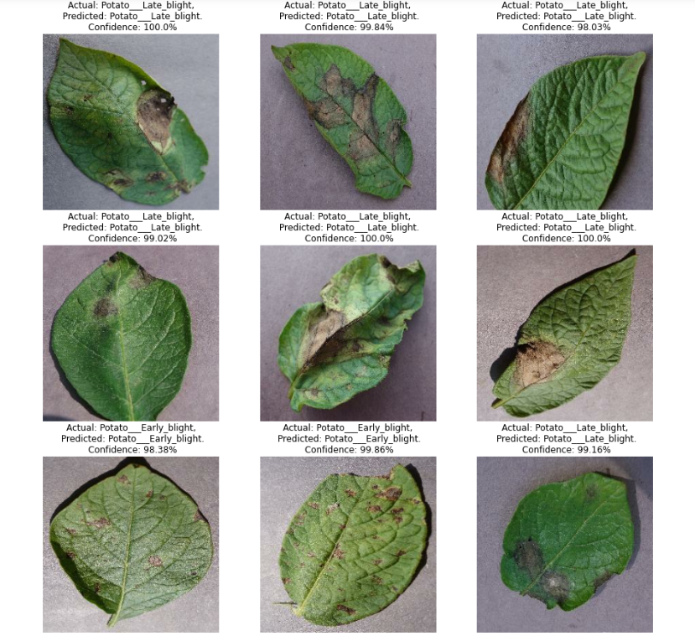

The following result is obtained by inference function discussed above, where it mentions the actual class the potato leaf belongs and the class predicted by the model for few images from the testing dataset, where it also depicts the confidence levels of the potato leaf images indicating how much the predicted values are matching to the actual values.

**References:**

[1] G. Athanikar and P. Badar, "Potato leaf diseases detection and classification system," International Journal of Computer Science and Mobile Computing, vol. 5, no. 2, pp. 76-88, 2016.

[2] M. Islam, A. Dinh, K. Wahid, and P. Bhowmik, "Detection of potato diseases using image segmentation and multiclass support vector machine," in 2017 IEEE 30th Canadian Conference on Electrical and Computer Engineering (CCECE), 2017, pp. 1-4.

[3] R. Pitchai, G. Sharath Kumar, D. Ashutosh Varma, and CH Madhu Babu, "Potato plant disease detection using convolution neural network," IICRR, vol. 12, 2020.

[4] A. Mushtaq et al., "Plant Disease Detection using CNN," Int. J. Adv. Res. Electrical, Electronics and Instrumentation Engg., 2010.

[5] S. I. Mohamed, "Potato leaf disease diagnosis and detection system based on convolution neural network," Blue Eyes Intelligence Engineering and Sciences Publication, vol. 9, issue 2, 2020.

[6] D. Tiwari, M. Ashish, N. Gangwar, A. Sharma, S. Patel, and S. Bhardwaj, "Potato leaf diseases detection using deep learning," in 2020 4th International Conference on Intelligent Computing and Control Systems (ICICCS), 2020, pp. 461-466.